**LIBRARY MANAGEMENT SYSTEM**

REPORT

**BACHELOR OF TECHNOLOGY**

**in**

**COMPUTER SCIENCE AND ENGINEERING**

By:

|  |  |  |  |
| --- | --- | --- | --- |
| *S.no.* | *Name* | *Roll No.* | *Registration no.* |
| *1.* | *SIVAJI MEENUGU* |  |  |
| *2.* | *KOTHA L N V SAI* | *66* | *11910317* |
| *3.* | *GUDIMETLA S V R K Y R KAUSTUB* | *67* | *11910318* |

**Courses Code: INT213**

**School of Computer Science and Engineering**

Lovely Professional University

Phagwara, Punjab (India)

**INTRODUCTION**

A Library management system is a software that uses to maintain the record of the library. It contains work like the number of available books in the library, the number of books are issued or returning or renewing a book or late fine charge record, etc. Library Management Systems is software that helps to maintain a database that is useful to enter new books & record books borrowed by the members, with the respective submission dates. Moreover, it also reduces the manual record burden of the librarian.

Library management system allows the librarian to maintain library resources in a more operative manner that will help to save their time. It is also convenient for the librarian to manage the process of books allotting and making payment. Library management system is also useful for students as well as a librarian to keep the constant track of the availability of all books in a store.

**ADVANTAGES**

* 1. It reduces the manual paperwork through it and gives proper information of books has been recorded automatically.
* 2. Librarian can update the information of books and manage availability and arriver record of the books.
* 3. It saves human efforts and time.
* 4. With the help of library management software, the customer can easily search and find the books.
* 5. Any book seeker can rent a book just by signing in with their details, and return it with the date of returning.

**APPLICATIONS**

* The Library management system is nowadays essential for schools, colleges, private libraries, and other organizations. They can use this software as the purpose of books issuing and returning for renewal. Moreover, this software helps the librarian to maintain information about book issuing and returning the book before the last date.
* Library management system are useful for such organization:

• School libraries

• Collage libraries

• Private libraries

• Reference libraries

• National libraries

• Public libraries

• Modern Public libraries

• Public leading libraries

**Libraries used in project**

* **Tkinter**
* **Squlite3**

**PROJECT SCREENSHOTs**

-

**Welcome page**

,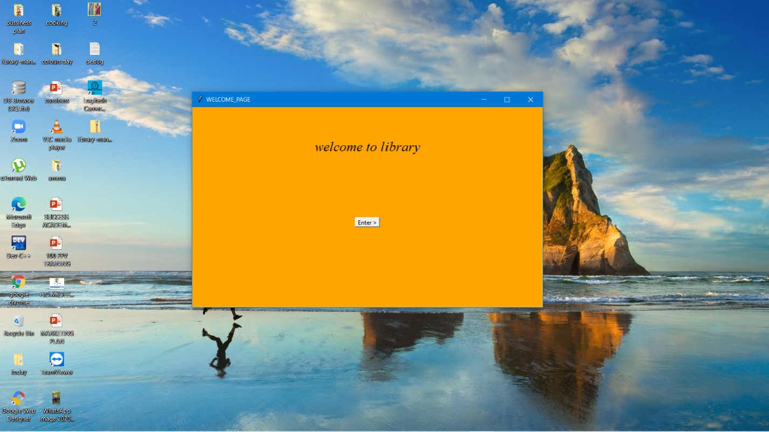

Login page

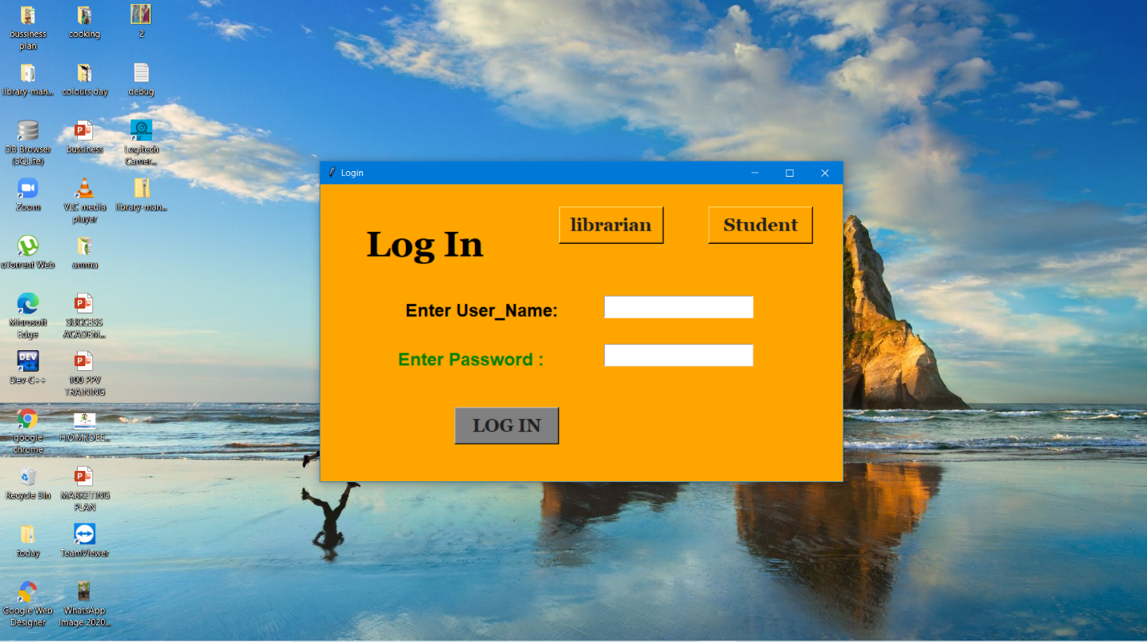

Librarian page

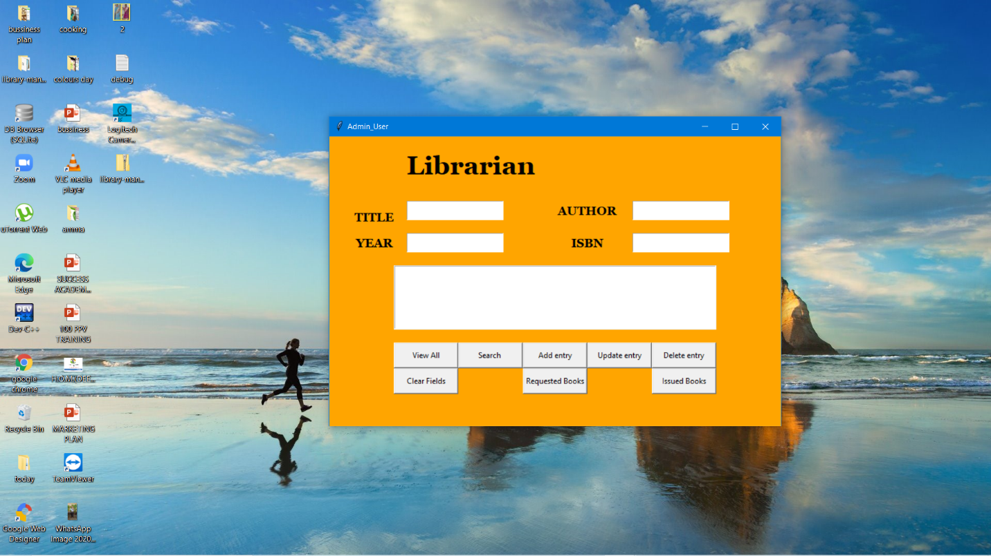

Student page

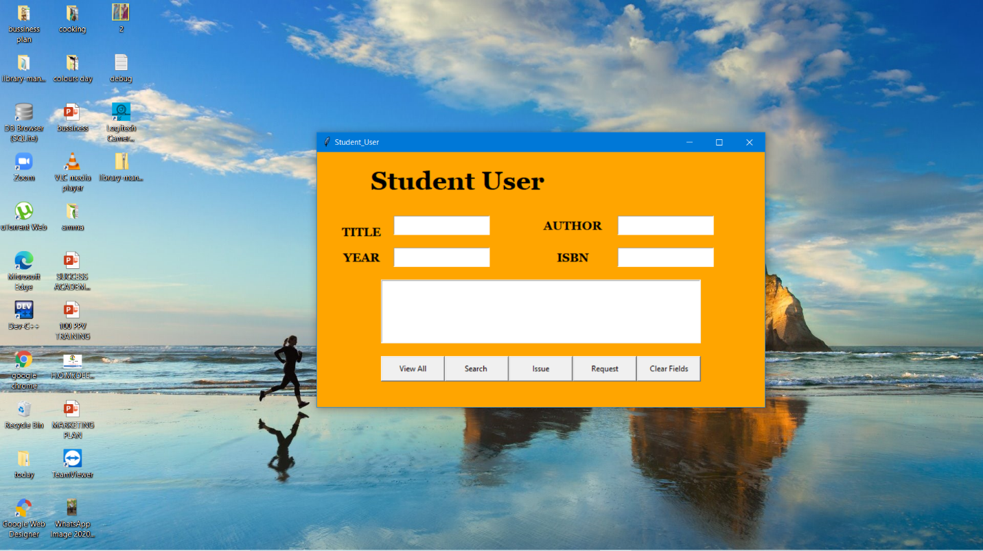

Student sign up page

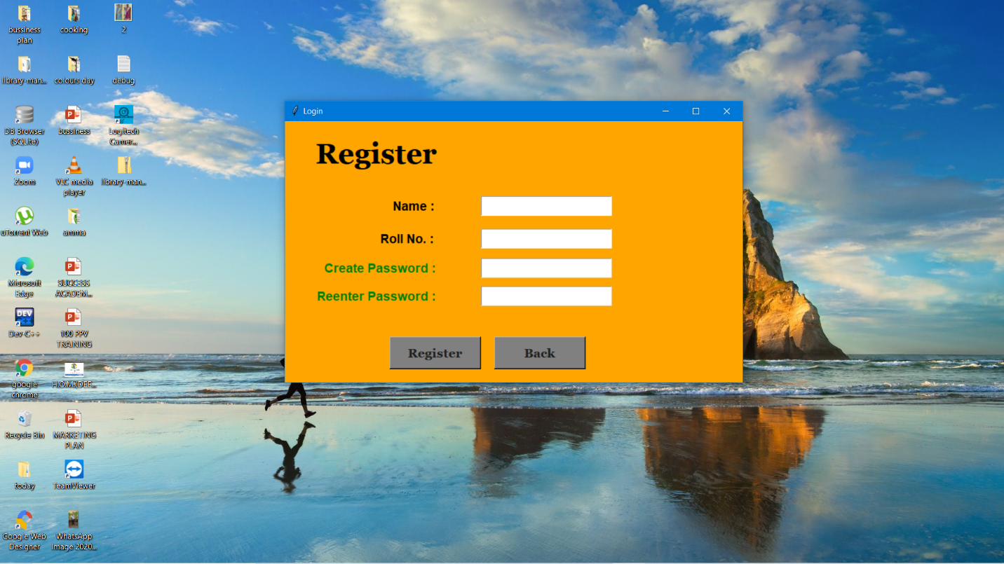

Coding part :